Analysis of Big Data and AI Publications

Authors:
- Viktor Korotkov: github
- Shitao Zhao: github
- Arystan Kamalov: github

Roles:
- Each member of the team made at least 3 queries and conducted analysis upon the obtained results. As well as the analytical part, the report is a joint effort.

Contents
1. Introduction 3
1.1 Problem Statement 3
1.2 Big Data Challenges 3
2. Data Description 2.1 Nature, Volume and Variety 3
2.2 Open Data / Linked Open Data Sources 3
3. Big Data and LoD Technologies 4
4. Link with the Practical Part 4
4.1 Questions Addressed Through the Data 4
4.2 Data Analysis 4
Section 1: General Publication Trends 4
Section 2: Thematic Structure of AI Research 5
Section 3: Geography of Research 7
Section 4: Authors and Community 8
Section 5: Institutions 9
Section 6: Quality and Impact of Research 9
Section 7: Evolution of Science and Trends 11
Section 8: Data Limitations 12
5. Conclusion. 13

1. Introduction

1.1 Problem Statement

AI and Big Data are deeply embedded in daily life, professional practice, and scientific research — from recommendation systems and LLMs reshaping information access, to doctors and scientists relying on ML tools in their workflows. Yet discourse around the "AI boom" remains largely subjective. This project uses real bibliometric data to objectively trace how the field has evolved, mapping shifts in research hotspots and the respective roles of academia and industry.

1.2 Big Data Challenges

The large volume, variability, and veracity of the scientific publication data are the hallmarks of a traditional Big Data problem, where the volume is large (hundreds of thousands of paper-author pairs), the variety is high (variable affiliation names, incomplete metadata, multiple-author strings), and the veracity is low (incomplete citation information, inconsistent venue names). This called for structured querying, cleaning, and metadata veracity auditing.

2. Data Description
2.1 Nature, Volume and Variety

Data was extracted from the DBLP computer science bibliography, covering publications from 1993 onward across major AI venues — machine learning (NeurIPS, ICML, ICLR), computer vision (CVPR, ICCV, ECCV), NLP (ACL, EMNLP, NAACL), and general AI (AAAI, IJCAI, KR, ISWC). The resulting dataset spans 13 SPARQL queries yielding records such as 483 361 paper–author pairs and 175 346 paper–affiliation pairs, alongside citation metadata and subtopic emergence timelines. Key challenges included inconsistent institution naming, missing affiliation coverage, and partial citation data via CiTO/OMID.

2.2 Open Data / Linked Open Data Sources

The choice of DBLP over Wikidata was based on an observation of severe data gaps regarding author affiliations and conference data. The DBLP data is openly available as a structured RDF data set via a SPARQL query service. This makes it particularly suitable for thorough querying. The citation data was obtained from OpenCitations Meta dataset (OMID).

3. Big Data and LoD Technologies

The project relied on DBLP's RDF knowledge graph, queried through its public SPARQL endpoint. Data is modelled using standard bibliographic vocabularies (Dublin Core, DBLP ontology) and linked to external citation graphs via CiTO. Thirteen SPARQL queries were written to extract thematic, geographic, institutional, and temporal slices of the data. Results were serialized to CSV and processed with Python (pandas, numpy), with visualizations produced in Plotly, Matplotlib, and Seaborn.

4. Link with the Practical Part

4.1 Questions Addressed Through the Data

Analysis was organized around four thematic clusters:
- Publication trends — volume growth since 2010 and alignment with technological milestones
- Thematic and geographic structure — dominant subtopics, country-level output, and shifting global balance
- Institutional and community dynamics — researcher productivity, collaboration rates, academic vs. industry roles
- Research quality and evolution — citation impact by subtopic and venue, emergence timelines, and metadata completeness

4.2 Data Analysis

Section 1: General Publication Trends
Since 1970, the field of artificial intelligence has experienced several distinct phases of publication activity. In the early decades (1970s–1990s), output was modest, typically a few hundred papers per year, reflecting the limited computational resources and research community of the era. A first notable uptick occurred in the early 1980s, coinciding with the commercialisation of expert systems and growing interest in rule-based AI.
The period from 2000 to 2011 showed steady but unspectacular growth, with annual output stabilising around 2,500–3,000 papers. The field fundamentally changed after 2012, when the deep learning revolution, marked by AlexNet winning ImageNet by a significant margin, triggered a structural break in publication volume. From 2012 onwards, output entered a sustained exponential phase.
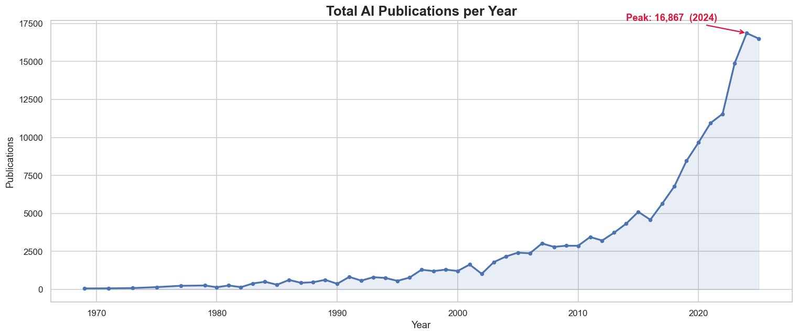
Publications crossed 10,000 annually for the first time in 2021, reached a peak of 16,867 in 2024, and show a slight moderation in 2025 (approx. 16,200), possibly reflecting partial data coverage for the most recent year. Cumulatively, more than 163,000 AI papers have been indexed across the tracked venues, with roughly 75% of that total produced after 2017 alone.
The year-over-year growth rate chart reveals that the early expansion of the field (1980s) was turbulent, with swings of ±40–170%, driven by the boom-and-bust of the first and second AI winters. The period 2003–2004 saw another sharp dip (approx. −40%), consistent with reduced funding after the dot-com collapse.
Post-2013, annual growth rates became more compressed and stable, typically in the +10–25% range, characteristic of a maturing but still rapidly scaling research ecosystem. The near-zero or slightly negative growth in 2025 may reflect the natural plateau after the exceptional 2024 peak, or lag in indexing.

Key Inflection Points:
- 2012 - Deep learning breakthrough (AlexNet); Computer Vision publications surge
- 2017–2018 - Transformer architecture introduced; NLP output begins accelerating
- 2020–2021 - Large language model era begins; NLP growth overtakes Computer Vision
- 2023–2024 - Generative AI hype cycle drives record total output

Section 2: Thematic Structure of AI Research
The corpus is categorised into four broad thematic areas. Computer Vision leads overall with 55,359 publications (28.1% of total), followed closely by Machine Learning at 54,492 (27.7%), General AI at 41,591 (21.1%), and NLP & Generative AI at 41,141 (20.9%). Semantic Web and Knowledge Representation together account for just 2.2%, reflecting their niche, specialised nature.
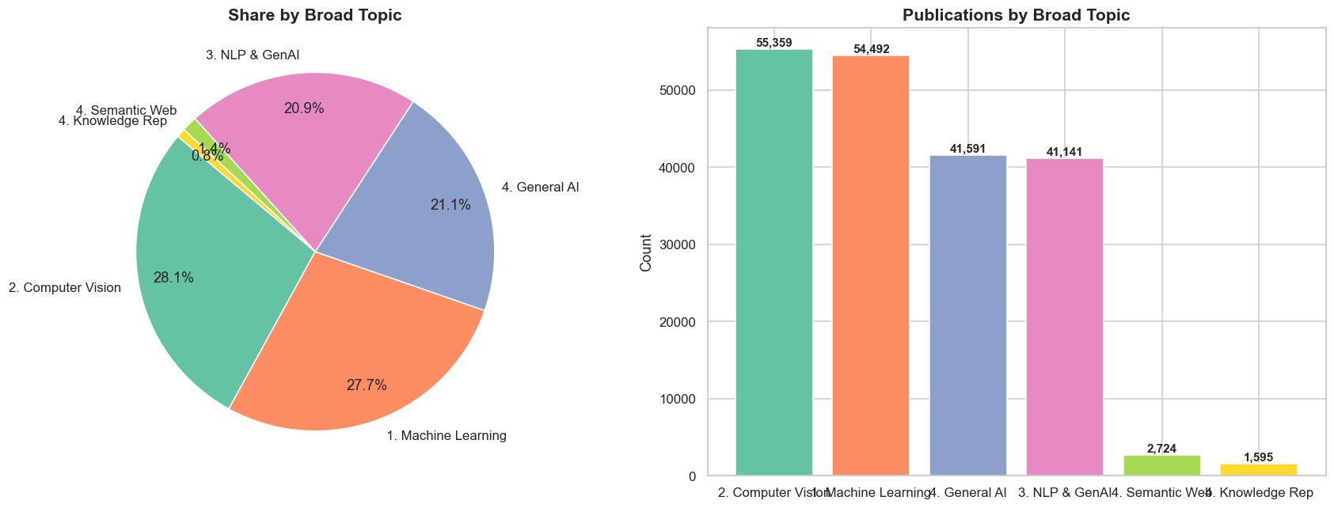
The near-parity between the top four themes is noteworthy: no single subdomain dominates the AI publication landscape absolutely. This reflects the interdisciplinary character of modern AI research, where advances in one area (e.g., deep learning architectures in Machine Learning) rapidly propagate into applications across vision, language, and reasoning tasks.

How topic popularity has changed over time?
The stacked area and line charts covering 2010–2025 reveal a dynamic and shifting landscape of research priorities.
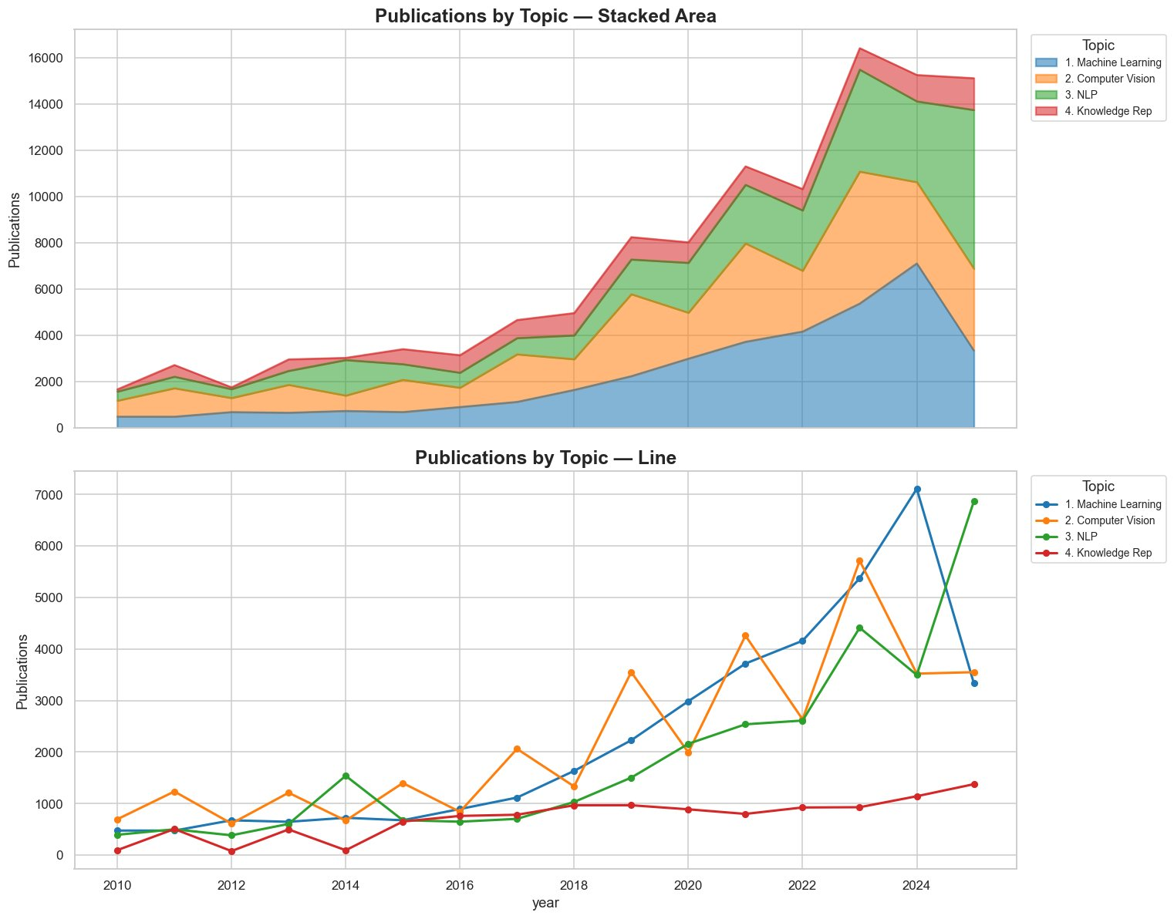
Computer Vision dominated output throughout the 2010s, driven by the ImageNet benchmark and the proliferation of CNN-based methods. Its absolute numbers peaked around 2023 at ~5,700 papers and have since declined slightly, suggesting a degree of market saturation as core visual recognition problems are considered largely solved.
Machine Learning showed the most dramatic single-year spike: from ~4,158 papers in 2022 to 7,106 in 2024, before dropping back to ~3,332 in 2025. This spike likely reflects the explosion of papers on large models, fine-tuning techniques, and RLHF methods during the generative AI wave.
NLP & Generative AI displays the most sustained recent growth trajectory, reaching 6,866 publications in 2025, overtaking all other categories for the first time. The growth is almost entirely post-2022, mirroring the GPT-3/ChatGPT inflection point. This is the single most important trend in current AI research output.
Knowledge Representation has grown slowly and steadily, rising from ~95–500 papers per year in 2010–2011 to ~1,375 in 2025, maintaining a roughly stable ~8–10% share of annual output.
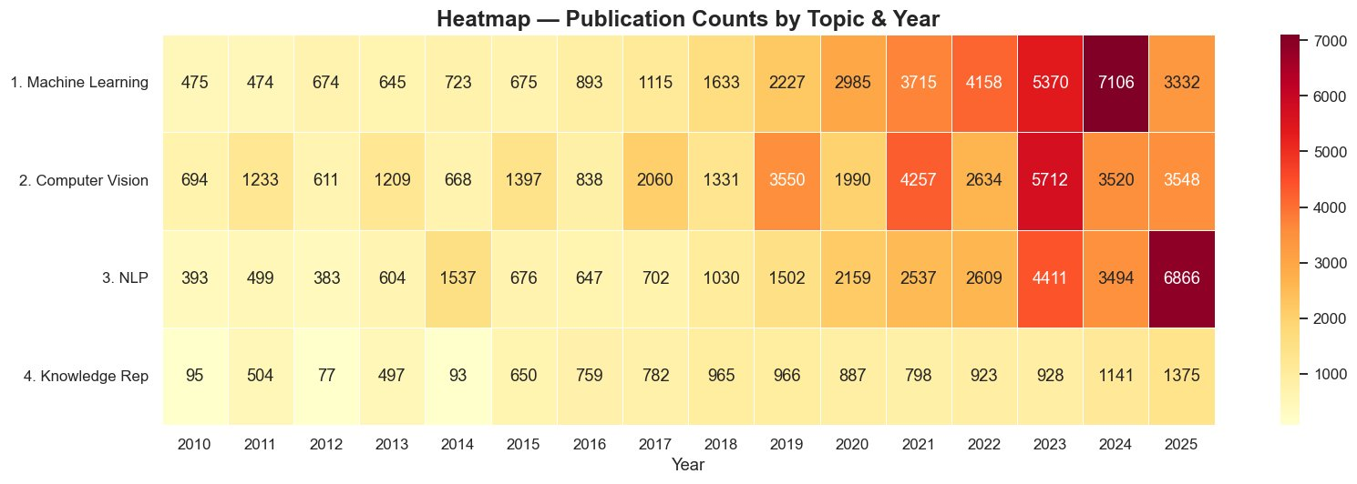
The heatmap confirms the narrative above. Machine Learning and NLP both show the darkest cells in 2024–2025, indicating record-high activity. Computer Vision's hottest period was 2019–2023, after which intensity moderated. Knowledge Representation remains the lightest row throughout, consistent with its niche but stable position.
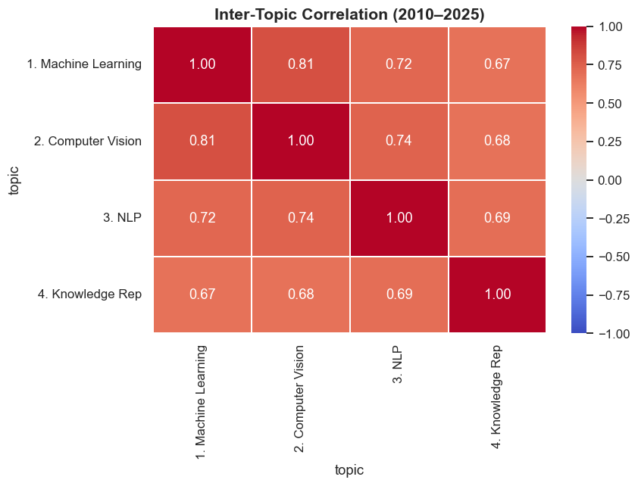
All four major topics are strongly positively correlated with each other, suggesting that the field grows as a unified ecosystem rather than as competing silos. The strongest pair-wise correlation is between Machine Learning and Computer Vision, confirming the deep methodological dependency between the two. NLP correlates most weakly with Machine Learning and most weakly overall with Knowledge Representation, reflecting some degree of thematic divergence.

Section 3: Geography of Research
The global AI research landscape is witnessing an unequivocal shift away from the traditional bipolar model to a multipolar one. While it is undeniable that the US and China lead the pack with respect to historical production, the exponential growth of China's production has ensured that it surpassed the US with respect to the volume of publications produced on an annual basis, with the shift becoming effective after 2023. As a result, the traditional dominance of the US has shrunk to 20% by 2025, compared to 50% just two decades ago, owing to the exponential growth of Asian nations like South Korea, China, and Singapore. The traditional European power centers like the UK and Germany have continued to hold steady, albeit with a relatively diminished role.
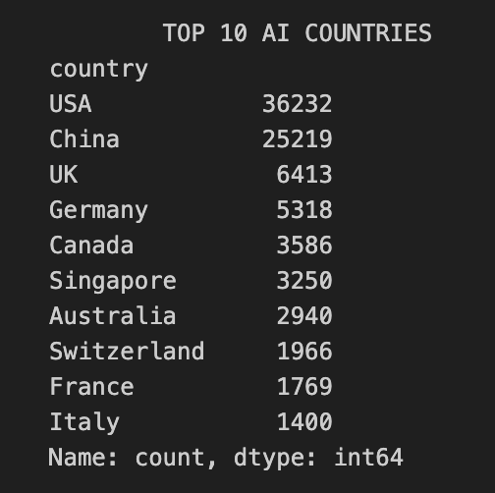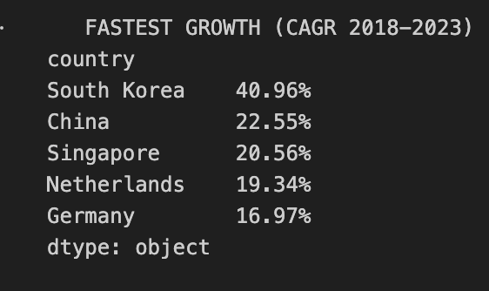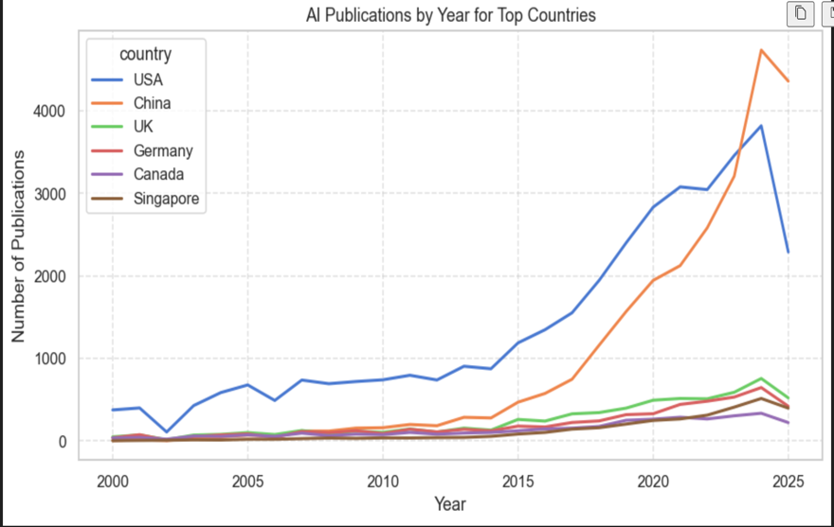
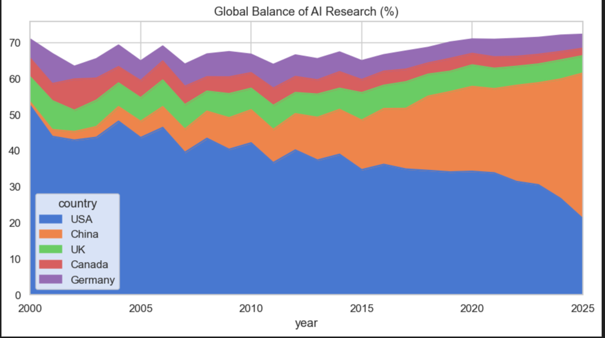

Section 4: Authors and Community
The landscape of researchers in AI research is marked by a state of extreme productivity asymmetry, wherein a micro-fraction of super-productive researchers account for a disproportionately large fraction of world output. At the same time, a significant paradigmatic shift is occurring toward a model of large-scale team science, wherein the average number of researchers per paper has more than doubled since 2000. Perhaps most intriguingly, an "international collaboration paradox" has been observed wherein, despite an increase in raw volume, the relative volume of cross-border collaborations has steadily decreased since 2015, dwarfed by the rate of growth of domestic output.
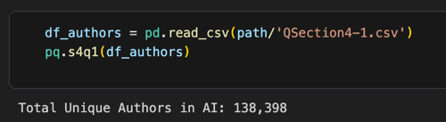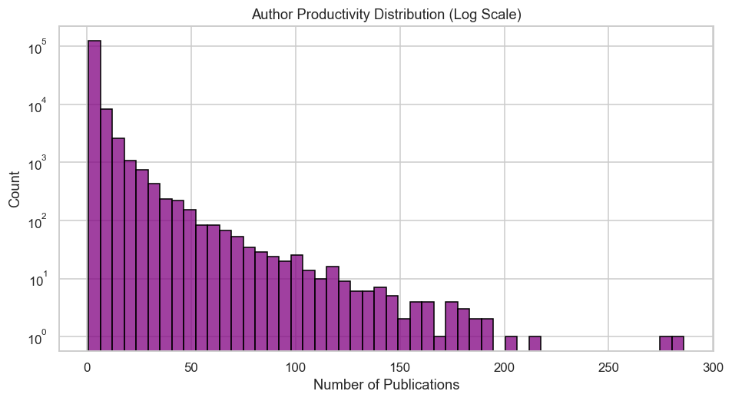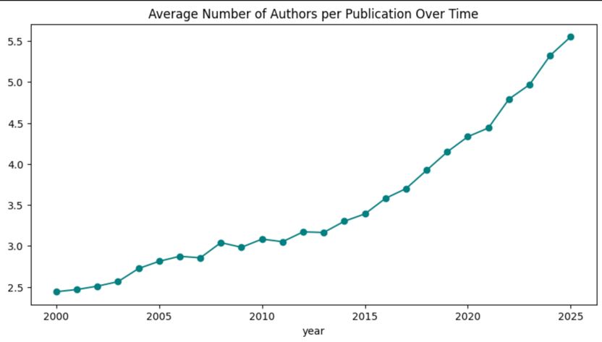
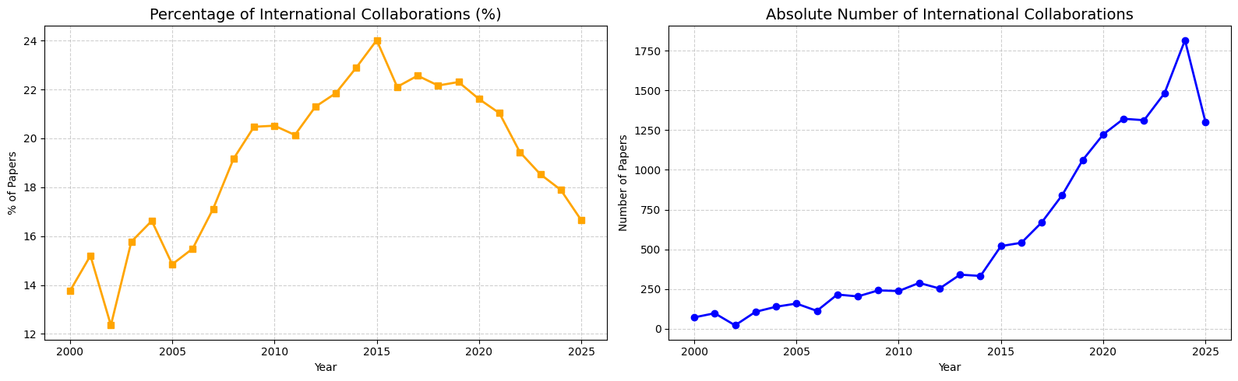

Section 5: Institutions
The global AI research is unequivocally dominated by the top-tier academic institutions, with Microsoft Research Asia being the only industrial entity within the top ten. In terms of longitudinal trends, the field has witnessed a paradigm shift with respect to historical versus contemporary volume leadership. Specifically, although CMU has the historical advantage, the explosive growth of NTU since 2010 has cemented the institution's status as the current volume leader. The top-tier academic institutions have diverse strategic focuses, with some, such as ETH Zurich and UC Berkeley, having highly specialized portfolios, while others, such as CMU and NTU, have more general AI portfolios. Ultimately, the public narrative of the industrial giants notwithstanding, academia is the primary driver of the field's exponential growth, with industrial research maintaining a stable yet strictly fractional footprint.
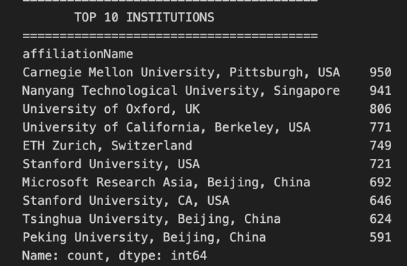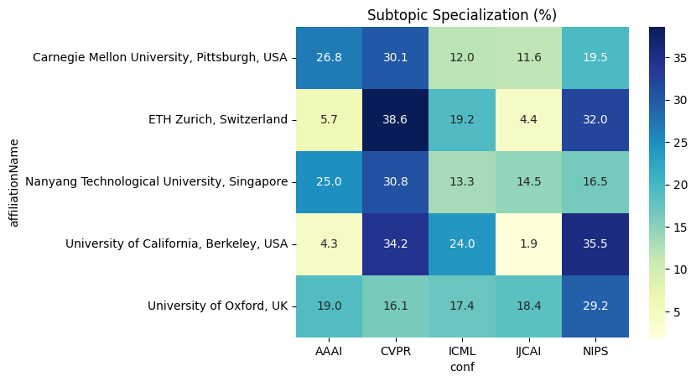

Section 6: Quality and Impact of Research
Which journals and conferences publish the most AI papers?
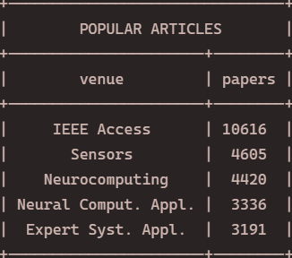
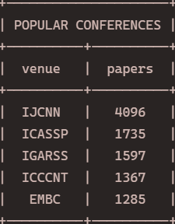
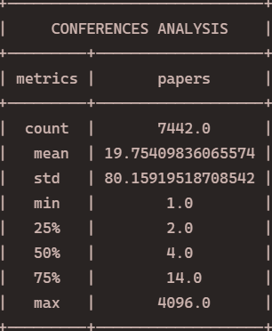
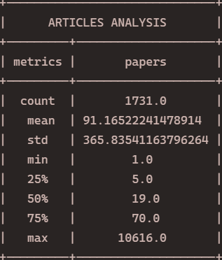
IEEE Access leads all journals with more than double the publications of the second-place venue — a dominance mirrored in conferences, where IJCNN holds a similarly wide margin. This concentration is confirmed by the distribution: the 75th percentile sits at just 70 papers for journals and 14 for conferences, with standard deviations of 365.8 and 80.2 respectively, indicating a strong skew where a handful of venues vastly outpace the rest.
The top-10 journals account for 23.8% of total community output, with IEEE Access alone contributing 28.2% of that share. For conferences, the top-10 take 10.4% of the sector — but since each of the top places averages only ~1% individually, dominance diffuses quickly beyond the very top. Of that 10.4%, IJCNN claims 26.7%. Full interactive graphs are available in the Jupyter Notebook.
Which AI categories are cited most often?
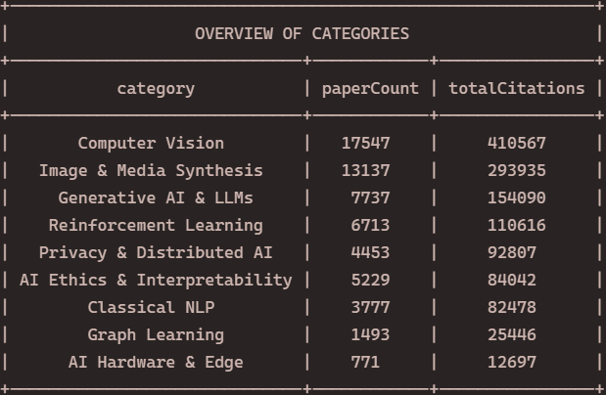
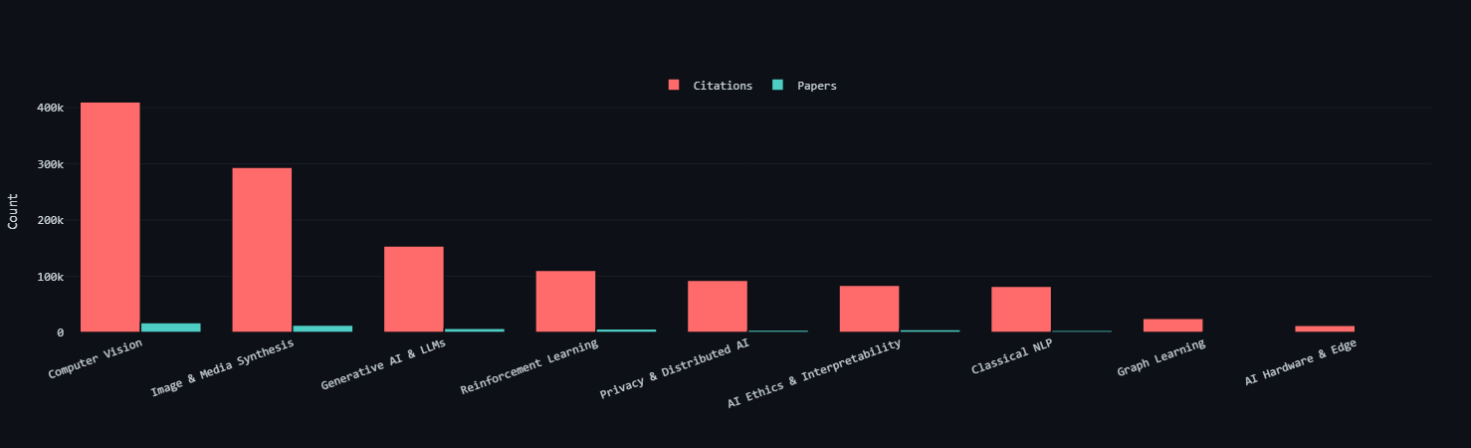
Across 9 categories, Computer Vision leads in both citations and paper count, with Image & Media Synthesis (covering GANs and Diffusion Models) as runner-up. AI Hardware is the least represented. Together, these two topics account for 50.4% of papers and 55.6% of citations; adding LLMs pushes those figures to 63.1% and 67.8% respectively.
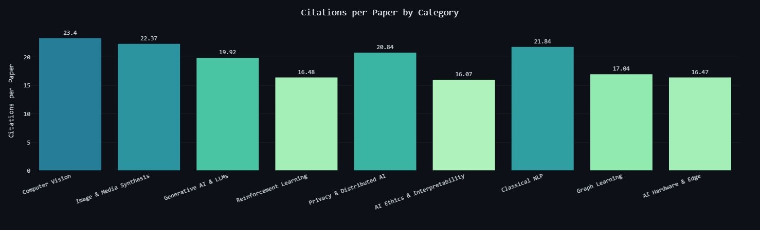
Computer Vision leads citations per paper at 23.4%, followed closely by Image & Media Synthesis (22.37%) and Classical NLP (21.84%). Generative AI & LLMs rank 5th at 19.92%, while AI Ethics & Interpretability has the lowest rate at 16.07%.

Section 7: Evolution of Science and Trends
How quickly do new categories enter the mainstream, and is there a time lag between fundamental and applied areas?

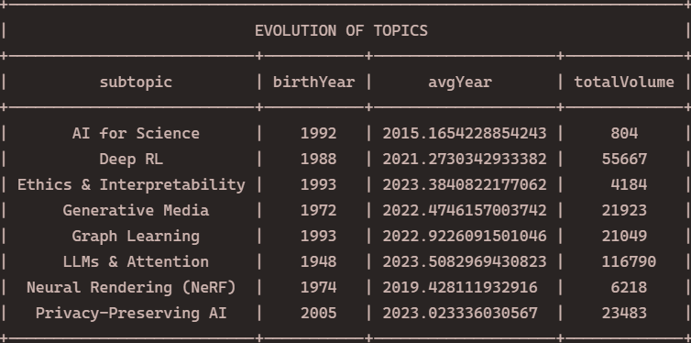
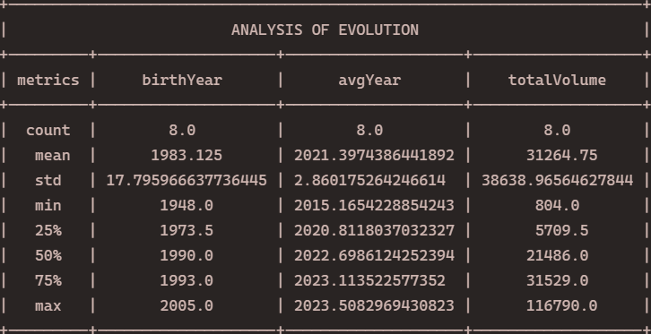
Privacy-Preserving AI is the most recently born category, while the data suggests LLMs & Attention as the oldest — an artifact of the regex also capturing transformer papers from electrical engineering. A more accurate reading is that classical neural networks and AI Ethics are among the oldest topics, the latter dating to the 1956 Dartmouth conference where the term "AI" itself originated. Notably, Ethics & Interpretability and Privacy-Preserving AI have the most recent average paper years, reflecting their continued relevance. LLMs & Attention lead in paper volume, followed by Reinforcement Learning, then Computer Vision and Generative Media. The LLM figure is inflated by the same regex issue, but given the field's current prominence, a top-two ranking remains credible regardless.
The birth year standard deviation of 17.8 (14.6 with correction) suggests the field consolidated rapidly, largely from the 1980s onward. The average paper year of 2021 with a standard deviation of 2.86 confirms high recent publication frequency, with each topic covered by over 31,000 papers on average.

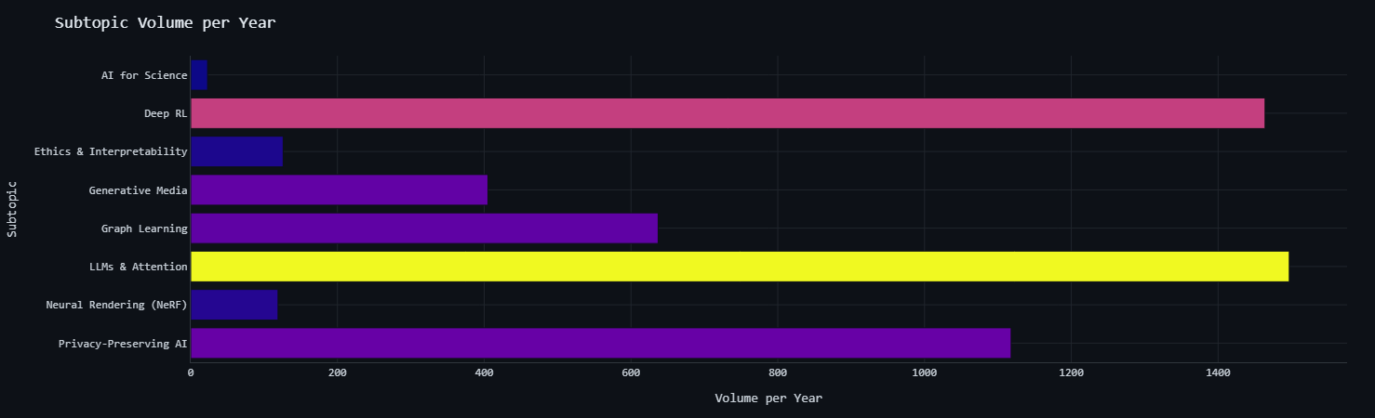
Subtopic volume per year as a bar chart. As we see, the most average volume is at LLM’s & Attention and Deep Reinforcement Learning, with Privacy-Preserving AI at the third place.
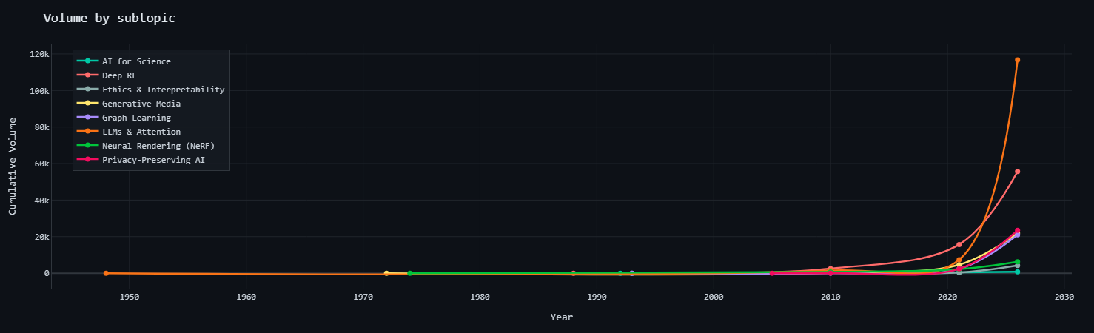
Evolution of frequency of publications within years. Recently we observe an exponential growth of publications in AI industry.

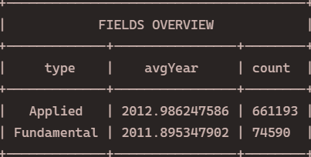

Applied AI significantly outpaces Fundamental AI in paper volume, reflecting a field increasingly oriented toward real-world and business applications over theory. The higher average paper year for applied topics further suggests this shift has accelerated in recent years.

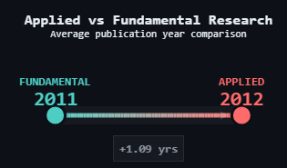

Section 8: Data Limitations
Which entities are worst represented?
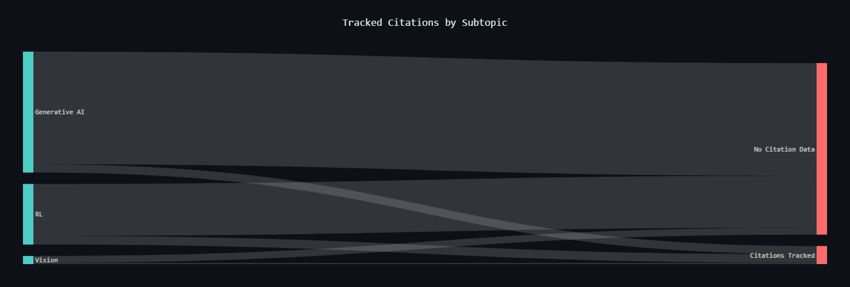
Citation tracking reveals a significant data limitation: across all categories, the majority of citations remain untracked. Affiliation information is also sometimes missing.
In addition, queries for LLMs and transformers capture papers from electrical engineering contexts, which distorts the timeline of emergence and increases paper volume. The classification into academic or industry sectors, as well as the categorization of AI topics, relies on heuristic rules rather than official labels. We ourselves “defined” what should be the categories for each question and tried to capture as many keywords from papers as we could to define a category. Therefore, categories vary from question to question and 1 paper, even if can be assigned to multiple categories, is assigned to only 1. Queries for questions were performed by team members separately rather than constructing one general dataset.
Finally, due to SPARQL endpoint timeouts, one large query had to be split into 3 smaller parts.
While these factors do not invalidate the observed trends, they should be considered when interpreting the results.

5. Conclusion
This study confirmed the key milestones of the AI boom with quantitative precision: the 2012 deep learning break, the 2017 Transformer shift, and the post-2022 LLM surge are all clearly visible in the publication curves. The near-equal weight of the four major subfields and academia's continued dominance over industry were perhaps less expected given prevailing narratives.
The most significant surprise was the international collaboration paradox — cross-border partnerships growing in absolute terms while shrinking as a share of total output, driven by China's domestic acceleration.
The central limitation is citation coverage: the majority of citations remain untracked via CiTO/OMID, constraining the reliability of the impact analyses. Affiliation metadata gaps similarly affect the geographic and institutional results.
Natural extensions include integrating a richer citation graph (e.g. Semantic Scholar), replacing regex-based topic assignment with embedding classifiers to reduce category noise, and building a canonical institution-to-country mapping to sharpen the geopolitical analysis.

